10th ASOSU House of Representatives
10th Congress

If found, please return to:
Name:

E-mail:

Phone:

MISSION
ASOSU is every student at Oregon State University. We exist as an organization to promote academic excellence, encourage the intellectual, social, cultural, and physical development of the student body, and enable the student body to its varied interests as citizens and members of the academic community through democratic representation.

VISION
We believe a better campus, a better community, a better experience happens when we come together.
You are a student. You have a Voice, Make it known.

MEMBERSHIP
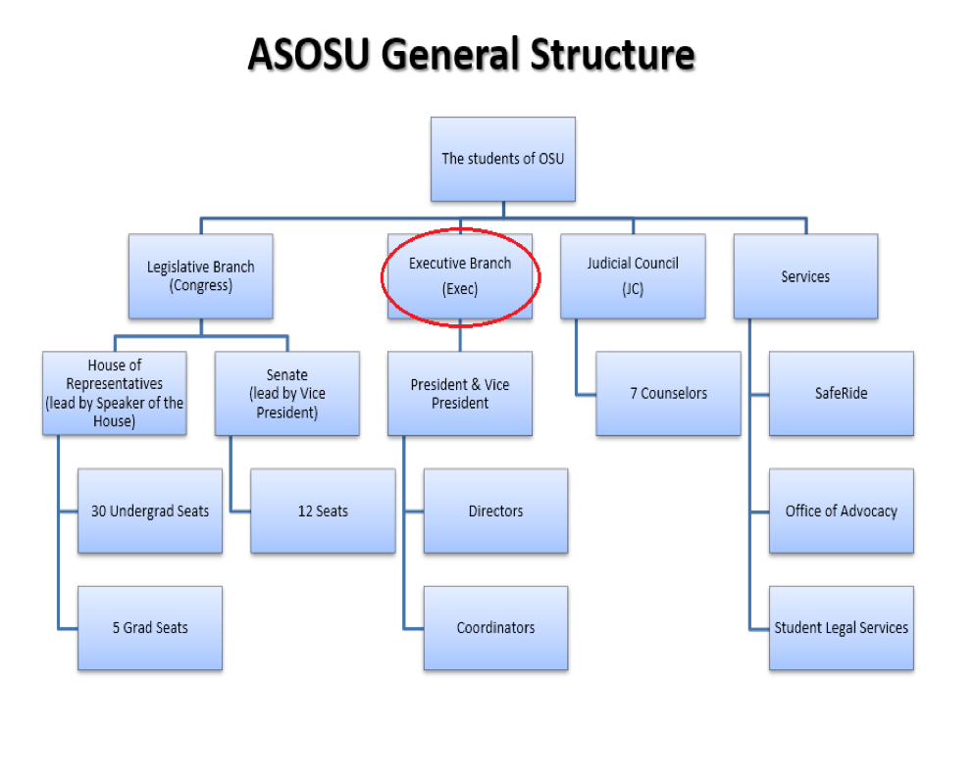
“All enrolled students of Oregon State University are members of the ASOSU. The ASOSU shall not discriminate on the basis of ability, age, color, ethnicity, gender identity/expression, marital status national origin, parental status, race, religion, sex, sexual orientation, or veteran status in any of its policies, procedures or practices.
STRUCTURE
ASOSU has many different branches and services to best serve the students of OSU. There are 3 branches in ASOSU along with a unique section of services that are provided to the student body.
ASOSU STUDENT BILL OF RIGHTS

- We believe that Oregon State University students have the right to express differing opinions and dissent on campus.

- We believe that Oregon State University students have the right to associate and assemble to collectively express, promote and defend common interests.

- We believe that Oregon State University students have the right to exercise the practice of religion free from discrimination.

- We believe that Oregon State University students have the right to academic advising that is accurate and can be relied upon for progress towards graduation.

- We believe that Oregon State University students have the right to have their voice heard in all university policymaking decisions that impact students.

- We believe that Oregon State University students have the right to a campus free of discrimination and harassment based on one’s race, color, gender identity or expression, religion, age, national origin, disability, marital status, parental status, sex, sexual orientation, genetic information or veteran status.

- We believe that Oregon State University students have the right to complete a course of study should the university discontinue a course of study.

- We believe that Oregon State University students have the right to due process in all university disciplinary processes.

- We believe that Oregon State University students have the right to an equal opportunity to learn and to participate and benefit from the academic community.

- We believe that Oregon State University students have the right to meet with and engage with course instructors and professors during their office hours.

- We believe that Oregon State University students have the right to the protection of student educational records and confidential information.

- We believe that Oregon State University students have the right to be graded in accordance with the course syllabus and the quality of their work.

Signed on May 9, 2017, by OSU President Ed Ray, 2016-17 ASOSU President Rachel Grisham and Faculty Senate President-Elect Jon Dorbolo.

Section 1: ASOSU Legislative Branch

Section 1A: ASOSU House of Representatives Structure
“Representatives shall represent the interests of the student body to the best of their abilities and shall stand ready to assist students in matters relating to the ASOSU.”

The ASOSU House of Representatives was established in 2009 and is tasked with representing the interests of the student body by handling all major budgetary allocations. There are thirty undergraduate and five graduate members chosen to serve the students at Oregon State University each year. Meetings are held every Wednesday in the Memorial Union at 7:00 p.m. with the exception of holidays and breaks.
Members of House pass two forms of legislation known as bills and resolutions. Bills are binding acts of Congress that affect ASOSU internally. Resolutions are non-binding acts of Congress which express the opinion of the students and/or the student government. When a resolution that is making a specific request to the university is passed, it is sent to the director of the department that oversees that issue. Resolutions are effective statements of support or disagreement that can be used to promote change on issues that affect students. Representatives also have the discretion to pass a joint bill or resolution with the ASOSU Senate.
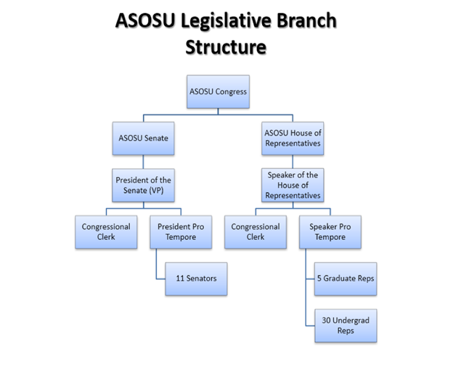

i) Committees
There are three standing committees within the House: Ways and Means, Appropriations and Budgets, and House Projects.
Ways and Means
The House Ways and Means Committee reviews all ASOSU annual budgeting requests, and sits on ASOSU’s student advisory board. The committee has the power to evaluate, amend, or adjust the proposed ASOSU budget from the ASOSU discretionary fund. The committee is also tasked with presenting the annual ASOSU budget to the Student Fee Committee (SFC).
Appropriations and Budgets
Appropriations and Budgets reviews and assists all Student Fee budgeting requests excluding the budget for ASOSU. Members will sit in groups of two in a non-voting capacity on the student advisory boards of all student fee funded units. The committee is also tasked with authoring a report that outlines the budget priorities for consideration by the SFC, prior to the SFC open hearing.
House Projects
The ASOSU House of Representatives is required to conduct two projects outside of House meetings, that is overseen by the Projects Committee. These projects must share a common purpose of achieving a tangible change in the institution, policy and make-up of OSU in a way that benefits the student body.
9th ASOSU House of Representatives Project JR-9.16: Representatives from the 9th ASOSU House of Representatives authored a joint resolution to establish a house project known as OSU With You (OSUWY). OSU With You is an on-campus student led personal safety escort program that meets students, staff, or guests of OSU at any location on campus and escorts them safely to their on-campus destination.
Independent Committees
Independent Committees shall report their activities and progress at least twice a term.

ii) House of Representatives Responsibilities
The ASOSU Constitution sets forth all of the expectations of the House of Representatives in Article II, and Article VIII, as well as Section 2 of the ASOSU statutes. The responsibilities are as follows:
- Terms of Office for Representatives and Speaker of the House shall begin at Noon on June 1st and shall end at Noon on June 1st of the following year.

- Attendance to regular meetings shall be mandatory for all Representatives and officers of the House of Representatives. Absence at more than two regular meetings per term shall result in the initiation of an Inquiry of Commitment by the Speaker of the House or Speaker Pro Tempore regarding the absent member, until four absences, after which their seat shall be declared vacant. (An inquiry of commitment is an official letter that questions the commitment of a member of ASOSU that is not fulfilling their position duties that are outlined in the ASOSU Constitution.)

- Vote by proxy shall not count against the attendance of the Representative. Proxies shall not be permitted during Joint Sessions of the ASOSU House of Representatives and Senate, or in matters of impeachment. Committee attendance shall be determined in committee bylaws.

- Office hours of Representatives shall be mandatory. Each Representative shall be required to hold one office hour a week excluding Finals Week. Each Representative shall submit their office hour and office hour location by the second week of each academic session to the Speaker of the House and the Congressional Clerk excluding finals week. All office hours are to be held on the Oregon State University campus at locations approved by the Speaker of the House. Any Representative who fails to hold office hours for three consecutive weeks or for four weeks in a single term (excluding week ten and finals week) shall have their seat declared vacant by the Speaker of the House. Office hours will be reported to the Speaker of the House and the Congressional Clerk.

- Representatives shall be seated on up to two Committees in the House of Representatives. Conference Committees and Independent Committees shall not be count towards a Representative’s two committees.
  - Members of the Appropriations and Budgets committee must sit on two student advisory boards of all the student fee funded units.

- Each elected and/or appointed ASOSU Representative shall be required to attend an information session/professional development series, as organized by the ASOSU Speaker of the House and President of the Senate, prior to the start of classes each Fall Term.

- Representatives shall attend one student created/sponsored event each term that they do not regularly attend. Representatives shall attend these events as official representatives of ASOSU and shall wear a nametag identifying themselves and their position within ASOSU. A report shall be given in the subsequent meeting of the ASOSU House of Representatives, detailing the event attended. If a Representative does not attend one event during the term, as delineated previously, that Representative will be given the equivalent of one unexcused meeting absence.

- Representatives shall complete mandatory cultural competency training without exception.

Speaker’s Expectations of House Representatives
- Representatives shall dress in business formal at Joint Congress. Business casual is strongly encouraged for regularly scheduled House meetings; however, nice casual is acceptable.

- Representatives will be respectful of differing views, opinions, and cultural backgrounds that are shared by other members of House.

- Representatives will refrain from using profanity while acting in capacities related to ASOSU.

- Representatives will lead by example and come to House meetings prepared. This entails bringing their House binder, ASOSU Constitution, and writing materials.

- Representatives will thoroughly research and contact departments of interest prior to submitting legislation.

- Representatives will schedule one 30-minute check-in with the Speaker every term, and one check-in with the ASOSU Advisor.

- Representatives shall keep any personal identities shared at House meetings confidential, unless otherwise stated.

- Representatives shall sign in and out of their office hours in the ASOSU office space.

iii) Roles
Speaker of the House
The body is chaired by the Speaker of the House, elected from the student body at large. The Speaker of the House presides over all regular and special meetings, coordinates activities, facilitates trainings, and oversees all operations of the House of Representatives. The Speaker of the House is a paid position, and only votes to break a tie.
2018-2019 Speaker of the House: Carol Moreno
Contact: asosu.house@oregonstate.edu Office Hours: By Appointment

Congressional Clerk
The Congressional Clerk is an appointee of the Speaker of the House, tasked with serving the ASOSU Congress. The Congressional Clerk oversees proposed legislation by House representatives as well as maintaining minutes for house and joint-congress sessions. The clerk is also responsible for archiving and maintaining congressional documents to be publicly accessible.

2018-2019 Congressional Clerk: Tatyanna Statum
Contact: asosu.legislative@oregonstate.edu Office Hours: By Appointment

Speaker Pro Tempore
The Speaker Pro Tempore is elected within the House of Representatives, and assists the Speaker in all their duties, acting as Chair of regular and special meetings upon the absence of the Speaker.

Committee Chairpersons
Committee Chairpersons preside over all regular and special meetings of their respective committees, coordinate activities, and oversee all operations of their respective committees. The Chairperson shall keep record of attendance and minutes of the meeting that will be submitted to the Congressional clerk within five days following each committee meeting. They will also submit the Committee’s bylaws to the Congressional Clerk within seven days of their passage to be approved by the Speaker.

Section 1B: ASOSU Senate Structure
The ASOSU Senate was established in 1940 and has had its current form since 2009. The Senate consists of twelve members elected at large from the student body for terms of two years. The Senate is tasked primarily with maintaining the ASOSU Statutes and is the primary law-making body of the ASOSU.
The ASOSU Senate holds weekly meetings on Tuesdays at 7 pm in MU 109.
President of the Senate
The ASOSU Vice President sits as the President of the Senate. Meetings of the Senate are started by the Vice-President and all Legislation passed in the Senate is signed by the President of the Senate. They also serve as a Non-Voting Member of all Committees.

President Pro-Tempore
If the President of the Senate is absent, the President Pro-Tempore serves as the President of the Senate. The President Pro-Tempore can step down during a meeting if they feel there is a conflict of interest and they would like to debate the issue as a senator. They are allowed to vote on all questions and have the authority to sign summons by the Senate and any Committees therein.

